5. CRUD Operations Using Hibernate
Hibernate:
- ORM Framework: Object-Relational Mapping for Java
- Database Abstraction: Write once, work with any database
- Entity Mapping: Map Java objects to database tables
- Query Language: HQL (Hibernate Query Language) & Criteria API
- Lifecycle Management: Automatic handling of object states
Object States in Hibernate
Hibernate defines three main states for an object:
- Transient: New object, not associated with any Session
- Persistent: Associated with Session, tracked by Hibernate
- Detached: Was persistent, Session closed, can be reattached
Understanding Persistent Objects
- Object associated with a Hibernate Session
- Has identity in database (Primary Key)
- Hibernate auto-detects changes in persistent state
- Can only retrieve ONE object using persistent object
- Use HQL for multiple object retrieval
- Flushed/synced when transaction commits

CRUD | Operation | Hibernate Method
Create | Insert | session.save()
Read | Fetch | session.get() / HQL
Update | Modify | session.update()
Delete | Remove | session.delete()

CREATE Operation - Steps
- Create entity object (TRANSIENT state)
- Open Session from SessionFactory
- Begin transaction
- Call session.save() to persist object
- Commit transaction
- Close session

Session Methods - Comparison
- save(): Returns generated ID, new object to DB
- persist(): Similar to save(), doesn't return ID
- update(): Updates existing record from detached state
- merge(): Copies state of detached to persistent
- saveOrUpdate(): save() or update() automatically
- refresh(): Reload object state from DB

Transaction Management
- Always use transactions for CRUD operations
- Automatic change detection in persistent objects
- Commit flushes changes to database
- Rollback reverts all changes
- Handle exceptions properly with try-catch
- Always close sessions in finally block
===================================================================================
Project: OVERALL STEPS to build Hibernate CRUD in Eclipse + MySQL
==========================================================

Summary of Overall Steps
Step | Task
1 | Install Java, Eclipse, MySQL
2 | Create database
3 | Create Maven project
4 | Add Hibernate + MySQL dependencies
5 | Add hibernate.cfg.xml
6 | Create Entity class
7 | Create Hibernate Util class
8 | Write DAO (CRUD)
9 | Write Main class
1 | Run program

A DAO stands for Data Access Object.
It is a design pattern used in Java to separate database logic from business logic.

Install Required Software
You must have:
- Java JDK 17
- Eclipse IDE for Java Developers
- MySQL Server + MySQL Workbench
- Maven (comes built-in with Eclipse, no need to install separately)

Create Database in MySQL
Open MySQL Workbench and run: CREATE DATABASE hibernatedb;
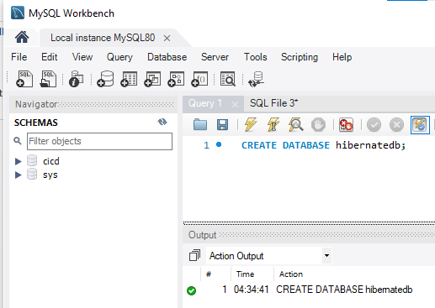
(Only this is enough. Hibernate will create tables.)

Create Maven Project in Eclipse
In Eclipse:
File → New → Maven Project → Quickstart Archetype
Give:
- GroupId: com.example
- ArtifactId: hibernate-crud
- Version: 1.0
This will create the skeleton project.
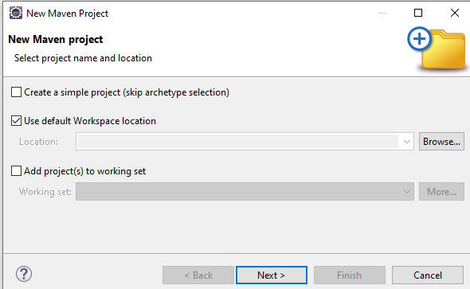
Type maven-archetype-quickstart, in the search box, then select third one.
org.apache.maven.archetypes → maven-archetype-quickstart
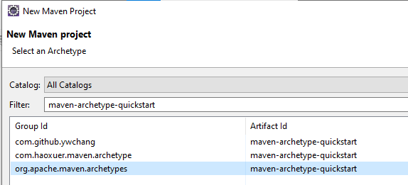

Click Next Button
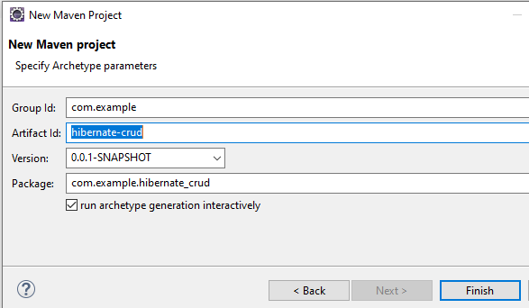
Enter Artifact Id: hibernate-crud //(Enter project name)
Click on Finish Button
It will take 1 or 2 minutes time to create a project structure.

I will show the project creation status in the bottom of the Eclipse IDE.
It will ask you, to press ‘Y’ in the console, then press ‘Enter’ button
It requires enough Internet speed.
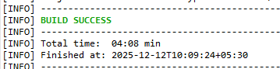
If project structure is not been showing, do as follows to show it.

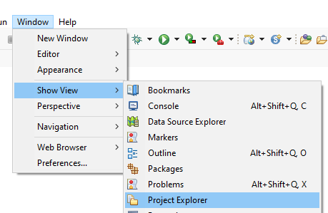

Now it is showing project structure as follows:

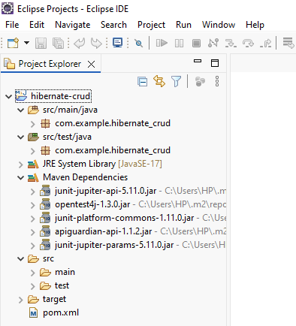

Clear Separation in Our Project Structure

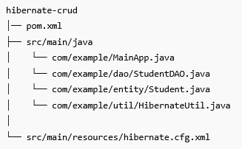
Type | Class | Example
Business Logic | MainApp.java | create, update, delete calls
Database Logic (DAO) | StudentDAO.java | session.save(), session.update()
Entity | Student.java | mapping class for table
DB Configuration | hibernate.cfg.xml | username, password, dialect

Right click on the src/main/java and select New-> package to create a new package.

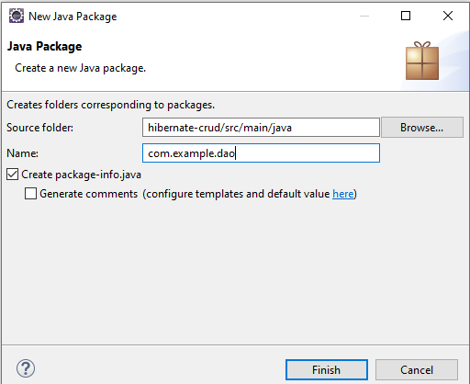

Inside this package, create a class as follows:

Enter a class name : StudentDao (In each word, first letter is capital)

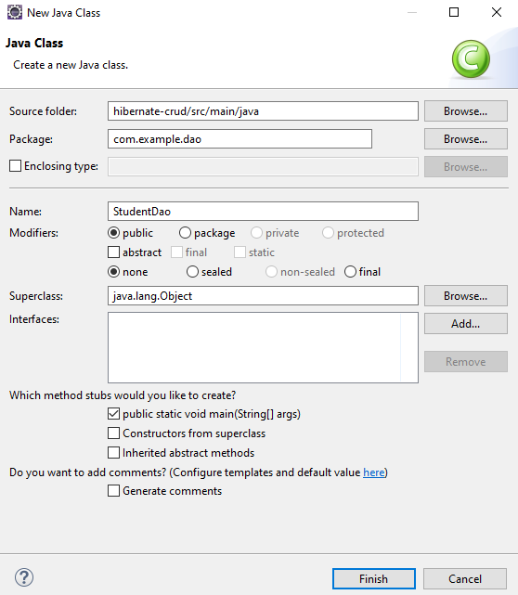

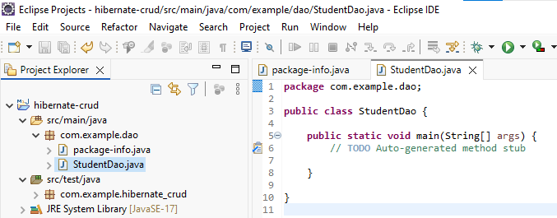

Create resources folder for Hibernate config

If src/main/resources is NOT visible:
- Right-click project → New → Folder
- Enter: src/main/resources
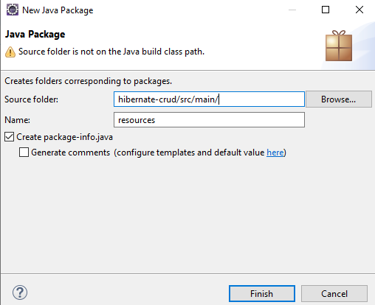
Then right-click it → New → File → hibernate.cfg.xml

Like that create other packages and files in it as per the required project structure.

Add Dependencies in pom.xml
You will add:
- Hibernate Core
- MySQL JDBC Driver
- JPA API (Jakarta)
- slf4j logging
(Eclipse will auto-download them.)
Add the following dependencies in the POM.xml file in between the <dependencies> </dependencies> tags:

<dependencies>
<dependency>
<groupId>org.junit.jupiter</groupId>
<artifactId>junit-jupiter-api</artifactId>
<scope>test</scope>
</dependency>
<!-- Optionally: parameterized tests support -->
<dependency>
<groupId>org.junit.jupiter</groupId>
<artifactId>junit-jupiter-params</artifactId>
<scope>test</scope>
</dependency>

<!-- Hibernate Core -->
<dependency>
<groupId>org.hibernate</groupId>
<artifactId>hibernate-core</artifactId>
<version>5.6.15.Final</version>
</dependency>

<!-- MySQL Driver -->
<dependency>
<groupId>mysql</groupId>
<artifactId>mysql-connector-java</artifactId>
<version>8.0.33</version>
</dependency>

<!-- JPA API -->
<dependency>
<groupId>javax.persistence</groupId>
<artifactId>javax.persistence-api</artifactId>
<version>2.2</version>
</dependency>

<!-- Logging -->
<dependency>
<groupId>org.slf4j</groupId>
<artifactId>slf4j-simple</artifactId>
<version>1.7.36</version>
</dependency>

</dependencies>

====================================================================

We can get all Maven dependency code from Maven Central or Hibernate/MySQL official pages:

https://mvnrepository.com/artifact/org.hibernate/hibernate-core

NOTE:

In this website, search for dependency name and search for the version which have more usage value should be consider. (No need to consider Latest one) as seen below.

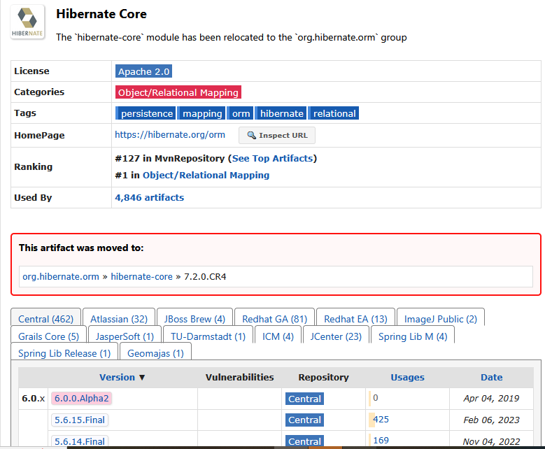

.==================================

Create Hibernate Configuration File
Inside: src/main/resources/
Create: hibernate.cfg.xml
This contains:
- Database URL
- Username/password
- Dialect
- Auto table creation
- Mapping class
=============================================================
<?xml version="1.0" encoding="UTF-8"?>

<!DOCTYPE hibernate-configuration PUBLIC
"-//Hibernate/Hibernate Configuration DTD 3.0//EN"
"https://raw.githubusercontent.com/hibernate/hibernate-orm/main/hibernate-configuration-3.0.dtd">

<hibernate-configuration>
<session-factory>

<property name="hibernate.connection.driver_class">com.mysql.cj.jdbc.Driver</property>
<property name="hibernate.connection.url">jdbc:mysql://localhost:3306/hibernatedb</property>
<property name="hibernate.connection.username">root</property>
<property name="hibernate.connection.password">root</property>

<property name="hibernate.dialect">org.hibernate.dialect.MySQL8Dialect</property>
<property name="hibernate.hbm2ddl.auto">update</property>
<property name="show_sql">true</property>

<mapping class="com.example.entity.Student"/>
</session-factory>
</hibernate-configuration>

NOTE:
1. In the above code, “hibernated” is the database name created in the Mysql.
2. Followed by next two lines, the word “root” is the username and password of the
Mysql.
3. In the <mapping> tag line, the word “Student” is the java class which we created
in the entity package.
If it is showing errors in the hibernate.cfg.xml file, then do as follows:
Even though your program is running successfully, Eclipse is still showing red error marks on hibernate.cfg.xml.
This is NOT a Hibernate error.
This is ONLY an Eclipse XML validation error caused by the DTD URL.
FIX 1 (Recommended) – Disable XML DTD Validation in Eclipse
Window → Preferences -> XML → XML Validation ->
Turn off validation options -> Click Apply and Close.
Project → Clean → Clean all projects
Now the red error on hibernate.cfg.xml will disappear.
=======================================================

Create Entity Class (Student.java)
Inside: src/main/java/com/example/entity/Student.java
Create a POJO class with annotations @Entity, @Table, @Id.
================================================
package com.example.entity;

import javax.persistence.*;

@Entity
@Table(name = "students")
public class Student {

@Id
@GeneratedValue(strategy = GenerationType.IDENTITY)
private int id;

private String name;
private String city;

public Student() {}

public Student(String name, String city) {
this.name = name;
this.city = city;
}

// Getters & setters
public int getId() { return id; }
public String getName() { return name; }
public String getCity() { return city; }
public void setName(String name) { this.name = name; }
public void setCity(String city) { this.city = city; }
}

===============================================

Create Hibernate Utility Class
Inside: src/main/java/com/example/util/HibernateUtil.java
This builds the SessionFactory.
package com.example.util;

import org.hibernate.SessionFactory;
import org.hibernate.cfg.Configuration;

public class HibernateUtil {

private static SessionFactory factory;

static {
factory = new Configuration().configure().buildSessionFactory();
}

public static SessionFactory getFactory() {
return factory;
}
}
==============================================================

Create StudentDAO
Inside: src/main/java/com/example/dao/StudentDAO.java
Write methods:
- save() → Create
- get() → Read
- getAll() → Read all
- update() → Update
- delete() → Delete
This file contains all CRUD operations.
======================================================
package com.example.dao;

import com.example.entity.Student;
import com.example.util.HibernateUtil;
import org.hibernate.Session;
import org.hibernate.Transaction;

import java.util.List;

public class StudentDAO {

// Create
public void saveStudent(Student s) {
Transaction tx = null;
try (Session session = HibernateUtil.getFactory().openSession()) {
tx = session.beginTransaction();
session.save(s);
tx.commit();
}
}

// Read by ID
public Student getStudent(int id) {
try (Session session = HibernateUtil.getFactory().openSession()) {
return session.get(Student.class, id);
}
}

// Read All
public List<Student> getAllStudents() {
try (Session session = HibernateUtil.getFactory().openSession()) {
return session.createQuery("from Student", Student.class).list();
}
}

// Update
public void updateStudent(Student s) {
Transaction tx = null;
try (Session session = HibernateUtil.getFactory().openSession()) {
tx = session.beginTransaction();
session.update(s);
tx.commit();
}
}

// Delete
public boolean deleteStudent(int id) {
Transaction tx = null;

try (Session session = HibernateUtil.getFactory().openSession()) {
Student s = session.get(Student.class, id);

if (s == null) {
return false; // Student not found
}

tx = session.beginTransaction();
session.delete(s);
tx.commit();

return true; // Successfully deleted

} catch (Exception e) {
if (tx != null) tx.rollback();
e.printStackTrace();
return false;
}
}
}
==========================================================

Create Main Class
Inside: src/main/java/com/example/MainApp.java
Write: Create student, Read, Update, Delete
===========================================================
package com.example;

import com.example.dao.StudentDAO;
import com.example.entity.Student;

public class MainApp {

public static void main(String[] args) {

StudentDAO dao = new StudentDAO();

// CREATE
Student s1 = new Student("RAMA", "Hyderabad");
dao.saveStudent(s1);

Student s3 = new Student("SAIRAM", "Guntur");
dao.saveStudent(s3);

int generatedId = s1.getId(); // ID after save
System.out.println("Generated ID = " + generatedId);

// READ
Student s2 = dao.getStudent(generatedId);
if (s2 != null) {
System.out.println("Student: " + s2.getName());
} else {
System.out.println("Student not found.");
}

// UPDATE
if (s2 != null) {
s2.setCity("Vijayawada");
dao.updateStudent(s2);
System.out.println("Updated City to Vijayawada");
}

// DELETE
boolean deleted = dao.deleteStudent(generatedId);

if (deleted) {
System.out.println("Student deleted successfully.");
} else {
System.out.println("Student not found for delete.");
}

System.out.println("CRUD Completed!");
}
}

===============================================================

Run the Project from Eclipse
Right-click → Run As → Java Application
You will see SQL queries printed in console:
Hibernate: insert into student ...
Hibernate: select ...
Hibernate: update ...
Hibernate: delete ...

Verify the output in MySQL
Check: SELECT * FROM student;
You will see your inserted data.
